A Formative Story – Using Formative I My Math Class
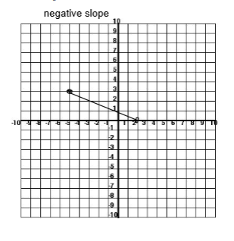
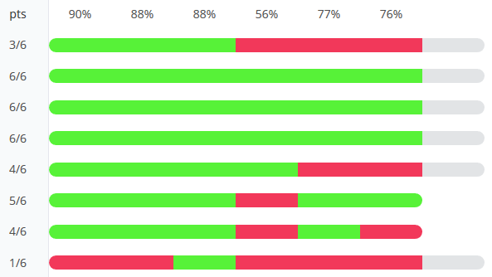
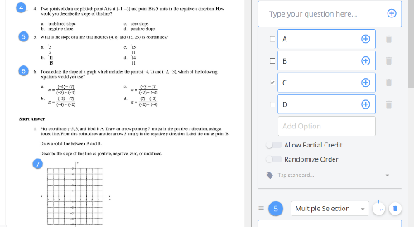
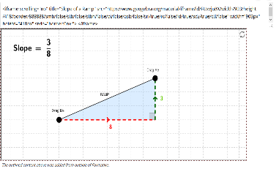
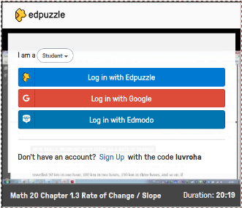
My Formative story is a simple yet powerful one. I was initially hooked using Formative by the annotating a document/PDF feature. However, as I explored other features and became a part of the amazing Formative Community, I was able to take my Formatives and the learning opportunities they afforded to another level. Therefore, I will share a story on a Formative I used to help my Grade 11 math students explore and show their understanding of slope. I decided to flip the instruction on this one by using a video I was able to edit inside of Ed Puzzle and easily embed into my Formative. I love the fact that Formative is very user and ‘app smash’ friendly. The video allowed students to receive content and check for understanding at their own pace. I followed this up with another embed idea that I learned about in community. I was able to provide students with an interactive slope tool through Geogebra. This was an excellent ‘hands-on’ opportunity to ‘play’ with and check out concepts they just learned from the video. Next, I provided a short formative assessment that I created and was able to upload and annotate. The formative assessment consisted of a few multiple choice and a short answer question. The data this assessment provided me with a great picture of individual and class understanding of the topic. Data that I used to provide whole class and individual instruction on this topic. I also included a very informal question asking students how they felt about their learning of this topic. Finally, I directed students to workbook questions if they were done the all the activities in this Formative. Formative was a ‘one stop shop’ and everything I needed for the lesson was in one convenient place. I loved the fact that this freed me up from being in front of the class to interact with students individually and in small groups as they worked their way through the learning activities. Students loved this and were able to easily work through the tasks and provide samples of their learning. The formative assessment data allowed me to be the guide on the side and make instructional decisions as the students needed them (like in this story I had to go back and review question 4 as it was cause some problems for students). Students responded well to all the activities embedded inside the Formative and we had deeper conversations about content and how it applied to a Roller Coaster project we were doing in Minecraft on the topic of slope as well (the Geogebra applet really helped students play with the different slopes and how that looked). I loved the show your work question as I was able to use the examples the students gave to compare, contrast, and concentrate instruction based on what I saw. The multiple-choice data was a great ‘snapshot’ into student understanding and both the students and I loved the immediate feedback. My story definitely reflects the daily successes I have using Formative. It has definitely been a game changer in my classroom and I continue to grow and understanding how to utilize this powerful tool in my classroom.
Formative Used - https://goformative.com/clone/HSXWNK (Rate of Change (Slope))

